11.67: Consider torques around the point where the person on the bottom is lifting. The center of mass is displaced horizontally by a distance 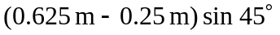 and the horizontal distance to the point where the upper person is lifting is 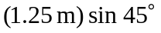, and so the upper lifts with a force of 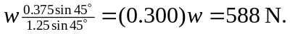 The person on the bottom lifts with a force that is the difference between this force and the weight, 1.37 kN. The person above is lifting less.

